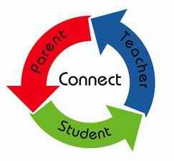

What is a Home-School Compact?

A Home-School Compact is an agreement that parents, students, and teachers develop together. It explains how parents, students and teachers will work toward becoming lifelong learners. Meetings are held each year to review the compact and make changes based on student needs. Parents are welcome to contribute comments at any time.

Effective Home-School Compacts:
- Link to goals of the School Improvement Plan
- Focus on student learning skills
- Describe how teachers will help students develop those skills using high-quality instruction
- Share strategies parents can use at home
- Explain how teachers and parents will communicate about student progress
- For all students who reside in residential facilities served by the Muscogee County School District, parental involvement correspondence and activities information will be mailed to each facility where students reside
2013-2014

Communication about Student Learning

- Connect-Ed messages
- Updates on the school’s website
- Parent-teacher conferences
- Current grades on the Parent Portal

School Information
Dr. Carla Henry, Principal
Mrs. Linda Sessions, Asst. Principal
1822 Shepherd Dr. Columbus, Ga. 31907
706-683-8732
http://jddaviselementary.weebly.com/

DAVIS ELEMENTARY
" Excellence without Exception"

Home-School Compact for Student Achievement 2016-2017

Revised 9/20/16

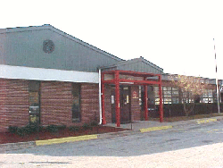

District Goals

The percentage of students in grades 3rd -5th scoring Proficient Learner or Distinguished Learner in Math and English-Language Arts (ELA) will meet or exceed the state average as measured by the Georgia Milestones Assessment (GMA) in the spring of 2017.

School’s Smart Goals

Academic/Instructional Goal: All students will increase Lexile levels by 30% based on pre and post scores on DRAs and/or Achieve 3000.

PBIS/School Climate Goal: J. D. Davis will score at least a 70% on the May 2017 Benchmarks of Quality (BOQ).

As a school, we will…..

- Help parents stay connected through multiple ways of communication. Parent-teacher conferences, Parent Portal, and the school’s website.
- Provide excellent educational experiences and a safe and nurturing environment conducive to learning.
- Engage students in active learning and monitor student progress to ensure student success.

As parents, we will….

- Communicate with my child’s teacher regarding any questions or concerns about my child’s academic performance.
- Make sure my child is at school and arrives on time prepared to have a productive day.
- Check homework folders daily.
- Know my child’s Lexile score and ensure my child reads 20 minutes each night for literacy practice.
Parental Involvement Does Make a Difference!

As students, we will…..
- Ask questions if we don’t understand our class room or homework assignments.
- Know my Lexile score and read for 20 minutes each night for reading practice.
- Practice our math facts each night.
- Strive to become a lifelong learner.

[Grab your reader’s attention with a great quote from the document or use this space to emphasize a key point. To place this text box anywhere on the page, just drag it.]
[Grab your reader’s attention with a great quote from the document or use this space to emphasize a key point. To place this text box anywhere on the page, just drag it.]
[Cite your source here.]

